Glory RBU-11 Setup for DynaCash CC-5000

CC-5000 To RBU-11 Cable (part #5KCBL-RBU):

The CC-5000 connects to the RBU-11 serial ports using a daisy-chained cable (#5KCBL-RBU) at the RBU-11 side. The RJ-45 cable end goes in the CC-5000 Port 1 connector. RBU-11 serial settings used are the factory default of 4800/7/E/1.

The RBU cable end with the main DB9 connector (has 2 cables going into it) is marked on the cable with CNIN1 and goes to the left side RBU serial connector (as viewed from machine front). That connector is marked CNIN1 on the RBU PCB. The cable end on the daisy-chain extension goes to the right side RBU serial connector. The daisy-chain extension is marked CNIN2. It is mandatory to connect these cable ends to the proper RBU-11 serial connectors, since the CC-5000 uses specific passwords for each connector!

The RBU-11 has a 3-position jumper on the right side PCB which will need to be set for serial operation. This jumper is right next to the Remote/Local switch. You will have to remove the metal PCB cover (has 2 small black Phillips screws) to get access to the jumper. The jumper needs to have it’s shunt between positions A and B (center to top). You will need to cycle RBU-11 power after changing the jumper. This jumper must be set properly. It “wakes up” the RBU-11 when the CC-5000 powers on and puts the RBU-11 to “sleep” when the CC-5000 is powered off. The CC-5000 expects the RBU-11 to be initializing (waking up) at the same time the CC-5000 gets powered on.

The final step is to ensure that the Remote/Local switch is in the Remote position.

CC-5000 To Dual Telequip Cable (part #5KCBL-TQD ):

The dual Transact coin dispenser machine can be controlled from either CC-5000 serial Port 2 or Port 3. The single CC-5000 cable #5KCBL-TQD controls both sides of the dual Transact. The cable has an RJ-45 end at both sides and plugs directly into the Transact, with no Y bridge cable adapter required. The cable is reversible – it doesn’t matter which end is plugged into the Transact or CC-5000. By choosing between Port 2 or Port 3, you can reverse which Transact cup the tellers get their coin from. Using Port 2 causes Teller Side A (left side of RBU-11) to get their coin from the left side Transact cup (as viewed from the Transact logo side, where coin isn’t visible). In that case, Teller Side B gets their coin from the right cup. Swapping the cable to CC-5000 Port 3 reverses the cups.

You can use an additional #5KCBL-TQD cable to use both Ports 2 and 3 at the same time, connected to two single cup Transacts. No additional configuration is required – just add the additional cable.

The Transacts operate at 2400/7/E/1, the same settings as are used with the PD dispensers.

CC-5000 To Journal Printer Cable (part #5KCBL-PRT):

The journal printer cable attaches to CC-5000 Port 4 and can be used with either a Citizens IDP-3550 impact printer or Star TSP-600 series thermal printer. The correct printer type must be profiled into the CC-5000 using the DynaSetup Profiler utility. The factory default profile uses the Citizens printer.

CC-5000 To DynaCash Teller PC Cables (part #5KCBL-USB):

A 15’ USB cable (#5KCBL-USB) for each of the teller PC’s is included in the CC-5000 DynaCash kit. For the teller on the left side of the RBU-11, use the CC-5000 USB 1 connector. For the teller on the right side of the RBU-11, use the CC-5000 USB 2 connector. Note – The DynaCash installation CD does a USB driver “pre-install”. For most PC’s, this avoids the hassle of locating a driver .INF file and going through the Plug ‘N Play Windows prompts. To avoid conflict with the driver pre-install, you should not connect the CC-5000 USB cables to the teller PC’s until after DynaCash has been installed. You may connect the cables first if the CC-5000 remains “off”.

CC-5000 To Network Cable (Optional):

This is provided by the end-user and is a standard CAT-5 Ethernet cable. As of December 2007, the only use for the CC-5000 LAN port is to reprogram the CC-5000 and for profiling over the network (profiling can also be done with the USB 1 connector). In most end user installations, the network cable can be omitted and the CC-5000 network feature can be disabled. In late spring 2008 we will release the DynaLog EJ archiver software which will use the LAN port for remote journal logging.

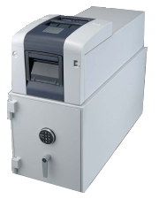
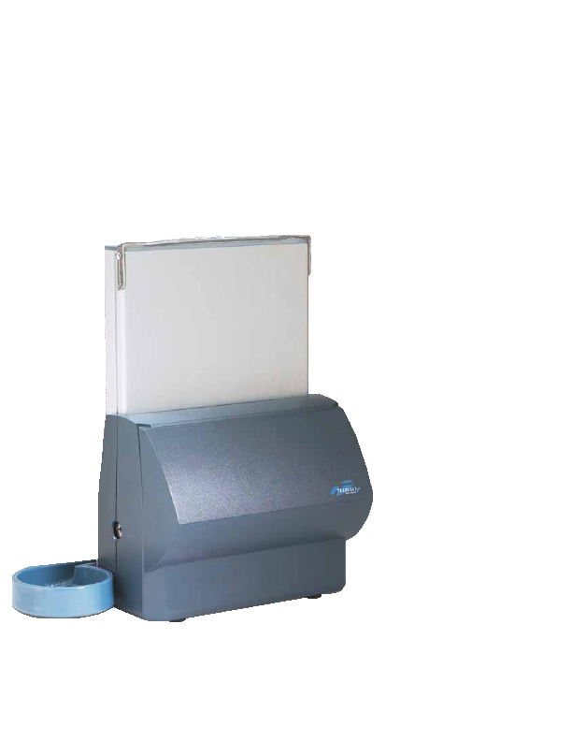
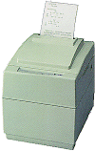
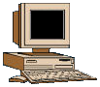
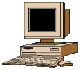
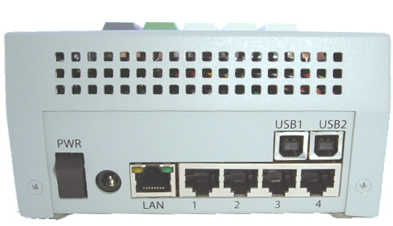
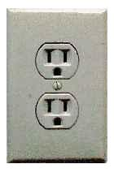
5KCBL-PRT
5KCBL-RBU
LAN
5KCBL-USB
5KCBL-USB
CC-5000 Terminal
Rear Panel
User Side B
User Side A
5KCBL-TQD
Optionally, 5KCBL-TQD may be plugged into Port 3 to reverse the sides that coin is dispensed to or 2 separate coin dispensers may be plugged into Ports 2 & 3.
See note above.

