DynaCash™ Features & Benefits for the Glory RBU-11

Summary:

DynaCash, the popular and robust text capture interface for the Glory PD dispenser series, is now available for the Glory RBU-11 recycler. DynaCash for the RBU was built from proven technology used for years with the PD dispensers. Program extensions were added to accommodate cash deposits via the RBU, with the ability to have the deposit counts transferred into the end-user’s PC application.

For those unfamiliar with DynaCash, it is a hotkey-driven Windows application that normally stays minimized on the Windows Taskbar. When the user presses a special dispense hotkey, DynaCash takes a picture of the text on the screen, then it searches through the “captured” text for phrases such as “Cash Out” and the dispensable amounts that accompany the “trigger” phrase. It then dispenses the proper amount and prints the transaction to the journal. For deposits, a pre-assigned deposit hotkey is pressed, at which time the RBU hopper opens to accept the cash. The DynaCash Windows application uses a separate model CC-5000 keypad with LCD that controls the RBU and manages reporting, adding users, automixing, and vault buys/vault sells by tellers not using DynaCash online.

Dispensing Features:

- Text Capture Database Interchangeable with PD Series – DynaCash setups done for the Glory PD dispensers can be used for RBU withdrawals, with no additional setup. The setup database only needs one or more deposit text captures added so the RBU can accept incoming cash. Likewise, DynaCash setups done for the RBU can be used immediately for PD installations. The deposit capture is ignored in this case. This conforms with Add-On’s policy of deploying pre-configured capture databases on the DynaCash setup CD, using a list of teller app names to install the captures that go with that teller app. A “recycler ready” teller app in our CD’s app list has a “-RR” suffix on the app name and can be used for either an RBU or PD installation.

- 3 Tier AutoMix – The CC-5000 offers a 3-tier, weighted automix algorithm. The weighting can be set up as either $1, $5, $10, $20, $50, $100, or $20, $10, $5, $1, $50, $100, or $100, $50, $20, $10, $5, $1. The mix quantities set up for each denomination are then dispensed in the order determined by the weighting scheme. 3 “tiers” of mix are available, with 2 variable cutoff points to determine when the mix ratios change. For example, the Tier 1 mix may be set as 10 pieces of $5, 4 pieces of $10, 6 pieces of $20, and 2 pieces of $50. The Tier 2 mix may be set as 12 pieces of $20, 6 pieces of $50, and 2 pieces of $100. A cutoff point of $350 might be chosen for the Tier 1 to Tier 2 transition, meaning that the Tier 2 mix preferences will be used if the dispense amount is greater than or equal to $350. Amounts below $350 would dispense using the Tier 1 mix. There is also a Tier 2 to Tier 3 cutoff which would be set to a higher value, to “roll” to the Tier 3 mix choices when the amount equals or exceeds that cutoff.

- Vault Buys – The CC-5000 has a Vault Buy key which may be used by “3rd party” tellers who are not dispensing online with the system. Vault Buys can be dispensed without the Vault Buy teller requiring access to the online PCs, since the CC-5000 is a separate keypad.

- Vault Buy Bundling – The system can be configured to bundle out the vault buys by denomination, so bills of different denominations don’t get mixed.

- Teller Transaction and Day Limits – The CC-5000 allows per-transaction and daily dispense limits to be imposed on the tellers. Different limits can be assigned to different tellers. Attempts to dispense when a limit is exceeded results in a warning message to the teller. The dispense can only proceed with a manager override.

- Local Withdrawal key – The CC-5000 is equipped with a Withdrawal key that allows any teller with CC-5000 permission to dispense by automix from the keypad. If the teller PCs go down, dispensing can still be done, using the CC-5000 as a “central station” RBU controller.

- Standalone Dispensing from PCs – DynaCash provides a Manual Hotkey option which lets the online tellers enter their own dispensable amounts at their PC, and nominate those amounts if needed. The manual amount entry box includes a built-in calculator.
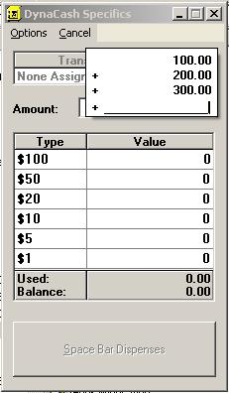
Manual hotkey enables amount entry by the teller.
Manual entry calculator feature.
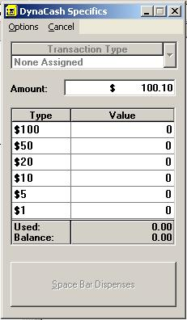

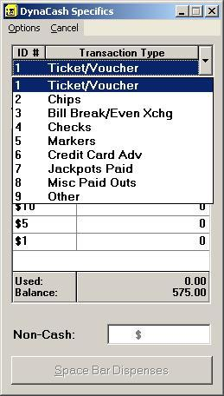
- Categorized Dispense Option – Up to 9 optional transaction type categories can be assigned for dispensing. The transaction types are helpful in casino installations to track dispenses by item type such as Markers, Poker Chips, Jackpots Paid, etc. Categorical totals are provided for each user who dispensed, and in the Grand Total Activity Report. The speed keys 1 – 9 can be used to select the category.
Category selection.

- Optional Non-Cash entry – DynaCash can be configured to
show a Non-Cash entry box. Any amount entry there subtracts from the available dispense amount. This can be used to log Not On-Us check cashing fees or split payments of cash and check (the check portion would be entered). Non-Cash totals are reported by DynaCash in the teller and GT Activity reports.

Non-Cash entry.

- Versatile Nominated Entry Options – For teller convenience, the DynaCash Specifics window can be configured to accept either piece counts or dollar amounts for the denominational entries. It can also be set up to have the lowest denomination ($1) at the top of the list (reverse order). When showing the highest denomination (typically $100) at the top, DynaCash uses a built-in AutoSeek feature to set the entry caret to the highest denomination that could be used for the amount. A dispense request of $45 would move the entry to the $20 position in the list. This saves the teller some additional keystrokes.

- Activator Mode – For many teller applications, DynaCash can be used in an “Activator Mode” which further automates the dispensing process. Instead of being initiated by a hotkey, the teller proceeds through their teller app transaction as usual. When they click a designated teller app button to finalize the transaction, DynaCash senses the button click and performs the dispense. An example of this is shown below, for the EZTeller32 teller application:
Clicking the Proceed button in EZTeller causes DynaCash to dispense the 500.00.
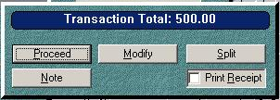

- Programmable Vault Timer – The CC-5000 can be configured to use an internal vault timer which prevents off-hours dispenses. Each day of the week can be programmed for a different range of hours.

- Duplicate Dispense Prevention – DynaCash has an interval timer that can warn the teller if they hotkey for a dispense twice within a specified time period (the default is 45 seconds) and the amount is the same for both dispenses. This helps prevent redundant dispenses when a hotkey is accidentally pressed twice. Going further with this concept, for many teller apps, a sequence or transaction number can be captured from the app and compared to the number captured in the previous dispense, providing a total lockout of re-dispensing while the number is identical.

- Segregated Vault Buys Option – The CC-5000 can be configured to keep Vault Buy totals separate from the other online dispense totals. Enabling this feature also adds a “Vault Buy History” report prompt to the CC-5000 Menu key loop. The Vault Buy History report prints all vault buy transactions in detail for each teller, in order of teller # and transaction #. This history has all Vault Buys back to the last daily Activity clearing.

- Easy Coin Dispenser Hookup - The CC-5000 includes serial ports for either a dual Telequip coin dispenser, or two single Telequip dispensers. There is no need for extra serial ports in the teller PC’s, to use the coin dispensers. Add-On Technologies provides a single cable for the dual Transact, which replaces the cumbersome “Y” cable with adapter used by Telequip.

- Inventory Removal Feature – Managers can remove RBU inventory by dispensing using the CC-5000 Vault Buy key. When a manager is signed on to the system, the Vault Buy key logs dispenses as “Inventory Removals” attached to that manager number.

- Simple Text Capture Setup – The DynaSetup text capture and intuitive cash trigger marking techniques make for a quick, hassle-free install process, when the teller app happens to be a new one not listed in the DynaCash CD teller app list.

- World-Class Text Capture Engines – Most teller application setups can take advantage of the Positional, Coordinate, T-Rex, TextCatch, or SnagIt text capture engines. These text capture techniques do not rely at all on screen resolution, font size, font smoothing or font color when retrieving the screen text. So it is much harder for a user to “break” the text capturing – in most cases it isn’t even possible. Most of the DynaCash capture engines allow you to capture the whole app window – no tight rectangles to draw inside text boxes.

- Informative Progress Windows – DynaCash displays a “Messenger” window during online cash dispenses. This window contains prompts telling the teller what to do next with the RBU:
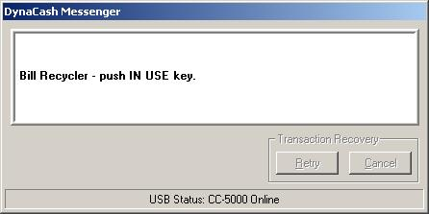
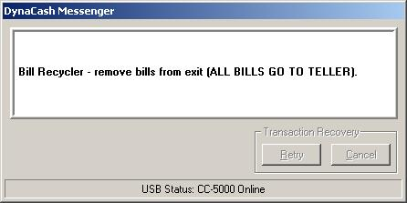
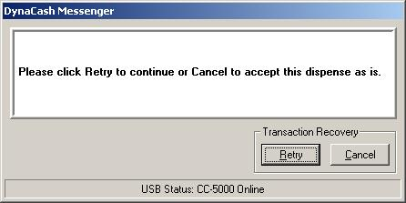
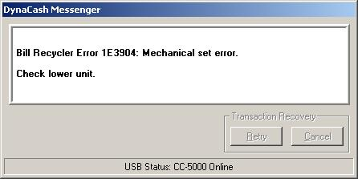

The teller is being prompted to press the RBU “IN USE” button to open the exit for retrieval of the dispensed bills.

The teller is being told to remove the exit bills, and that they belong to the teller’s customer.

An RBU error in the lower unit has occurred. As the error gets corrected, various status messages or prompts will be shown by Messenger.

An RBU error has been corrected. Now the teller is being prompted whether to complete the rest of the dispense or not.

Deposit Features:

- Near Full Denomination Warnings – The CC-5000 can be preset for denomination “near full” warnings. The range is 1 – 4000 bills per denomination, allowing for rollover stackers.

- Convenient Escrow Recovery – RBU escrow can be recovered without quitting the deposit transaction.

- Store & End Deposit Finish Feature – When no more bills will be deposited, the teller can click the “Store & End” button to store the escrow bills and then quit the deposit with a single command.

- Categorized Deposits Option – DynaCash can be configured to keep deposit totals by category.

- Deposit Limits (still in development) – Each teller can be assigned a deposit limit that prevents them from depositing more than the limit, on a per-transaction basis.

- Mutilated Bills Tracking – Mutilated bill counts can be entered (by denomination) in the online deposit window and have their totals tracked separately. Mute counts get included in the deposit counts transferred into the teller app.
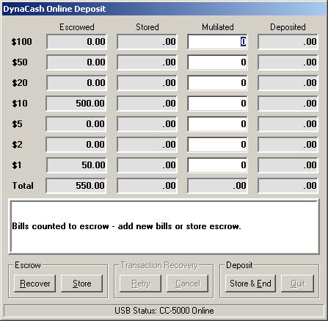
Escrow recovery allows transaction to continue.
One click to store and finish deposit.

- Standalone Deposits Option – With one click of a check box in DynaSetup, DynaCash can be put in a standalone deposits mode (no teller app required). No separate program or part number is required for standalone operation. Since DynaCash also offers a manual dispense hotkey, it can be put in complete standalone mode for both deposits and withdrawals. Or it can be used in “teller app dispense/standalone deposit” or “standalone dispense/teller app deposit” modes.

- Proper tracking of Non-Recyclable bills – For non-standard RBU stacker configurations (such as two $20 stackers with no $50 stacker), if the RBU is set up to accept any $50 bills deposited into the divert bin, DynaCash properly accounts for those bills in the reports, and will transfer those counts into the teller app.

- World-Class Deposit “Wedging” Algorithm – RBU deposit counts get accurately transferred into the teller app Cash In window(s) using Add-On’s instantaneous keyboard wedge function. This function was derived from the popular TellerCounts™ count transfer program for the Glory GFR series. “Prefix” and “Suffix” key macro actions provide absolute versatility in the setup of app windows for deposits. An optional delay can be set to slow down the transferred count entries a bit for teller apps that may need time to “digest” each denomination as those counts arrive.

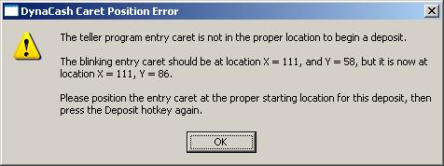
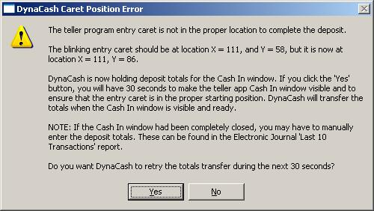
- Caret Tracking Option – To prevent counts from transferring (wedging) into the wrong entry areas in the teller app, DynaCash can track the entry caret for most teller apps. If the starting position for the caret is wrong, DynaCash will warn the teller at the start of a deposit. The teller must then move the entry to the correct starting location (typically the $100 denomination entry) before the RBU deposit process can begin. When the RBU has finished, caret position gets tested again to ensure that the teller didn’t move from the valid start location during bill storage. The teller gets 30 seconds to correct the situation:

- Counterfeit Detection – DynaCash is the only 3rd party RBU interface that fully implements that machine’s counterfeit detection ability, during deposits.

- DOS Console Teller App Compatibility – DynaCash works nicely with old DOS teller apps if they are running in a console window. Deposit caret tracking also works well with DOS consoles.

- Window Forcing – After an RBU deposit has begun, a teller may inadvertently bring other windows in front of the teller app Cash In window. When they finish the deposit, DynaCash “forces” the Cash In window to the front so the counts will reliably transfer into the window they are meant for.

- Vault Sells – The CC-5000 has a Vault Sell key which may be used by “3rd party” tellers who are not depositing online with the system. Tellers can sell their excess drawer cash to the RBU without the Vault Sell teller requiring access to the online PCs, since the CC-5000 is a separate keypad.

- Inventory Loads – Managers reload the RBU by using the CC-5000 keypad, which keeps them from interfering with tellers at the PCs.

- Escrow Printing – The system can be configured to print escrow bill removals to the journal printer, as an extra audit precaution.

General System Features:

- Dual Control – For online activities such as teller logon/logoff, dispensing, and depositing, the teller would use DynaCash at the PC to initiate the activity. However, the CC-5000 LCD also has it’s own set of prompts that match the prompts in DynaCash. If it’s in a more convenient location, the teller can watch and respond to prompts on the CC-5000 rather than at their PC. For instance, if the CC-5000 is closer to the RBU than the teller PC, bill storing can be started at the CC-5000 instead of at the PC.

- No Teller PC COM Ports – The CC-5000 has all of the required serial ports for the RBU, printer, and coin dispenser. Attachment to the teller PC is with one USB cable. There are no USB to Serial Converter cables required – the CC-5000 uses Plug ‘N Play USB drivers, totally avoiding COM port issues. The CC-5000 USB driver is pre-installed when DynaCash is installed, so Plug ‘N Play is automatic (no .INF driver files to browse for). The standard 15 foot USB cables shipped with DynaCash can be extended by 16 feet with an optional USB extender cable available from Add-On.

- Local Verify – 3 bill verifying modes (Mix, Batch 100, Variable Batch) are available at the CC-5000 keypad. Verify Mix counts mixed bills (no batching). Verify Batch (100) counts the first denomination detected by the RBU-11 and batches at 100. Verify Batch (Variable) prompts the teller for a 1 – 400 batch preset entry, then counts the first denomination detected by the RBU-11 and batches at the entered quantity. Verify counting can go on as long as needed, summing into one set of totals. If an RBU-11 error occurs during verifying, the teller has a choice to continue verifying (after the error is corrected) with any new counts adding to previous counts (where the previous counts were for bills that had already been removed from escrow). In this case, the counts do not reset. When the teller finishes verifying, they have the option to print the verify totals to the audit trail or not. Verify on the CC-5000 does not require a teller logon – any teller can count their bills on the RBU-11, even if they don’t have a teller # and PIN in the CC-5000 “authorized teller” list. Verifies are not stored in transaction history memory. The two batch Verify modes allow the teller to select a “New Denomination” option that restarts Verify mode for a different denomination.

- Reconcile Diverted Bills – Management can easily process rejected bills at the CC-5000. The process is similar to doing an Inventory Removal.

- Transaction History – Up to 4000 transactions are stored in a “rollover” transaction history memory. The history can only be cleared by using the top level Admin password. History can be printed at any time, by users with manager-level access. Transaction types stored in History include Inventory Loads, Inventory Removals, Reconcile Diverts, and all teller withdrawals and deposits.

- Journal Printer Options – The CC-5000 can be used with either a 40 column Citizen’s IDP-3550 impact printer (red and black printing) or a Star TSP-212 48 column thermal printer. A future option is an Electronic Journal file archiver (DynaLog) with remote Viewers. Once the archiver is available, the system could be configured for paperless usage.

- Electronic Journal – DynaCash has a built in Electronic Journal which offers the most common reports, including a quick view of the last 10 transactions:
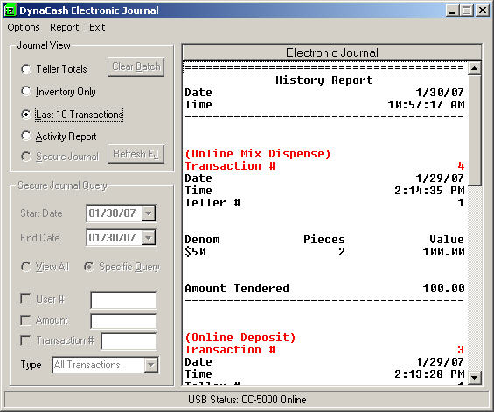

- Password Control – The internal RBU passwords can be managed through the CC-5000 Profiler program, which is also password protected.

- Automatic Logoff Option – A delay interval can be set to log off users who have had no system activity within the delay time. Time intervals of 1 – 60 minutes can be programmed.

- Additional Security Features – Some of the Manager Menu key prompts (CC-5000) can be further locked down to prevent access by “regular” managers – the Admin password would be required. Teller setup (adding, editing, deleting) can also be locked down to require the main Admin person for teller changes.

